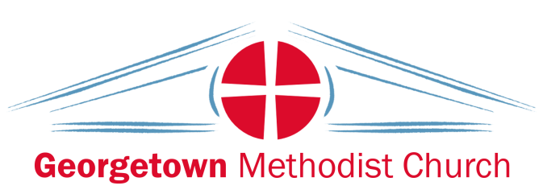

BOOKING FORM

Name of person booking Hall:……………………………………………………………………….

Tel:.......................................... Mobile:……………………………………………….

Address:………………………………………………………………………………………………………………………………………
……………………………………………………………………………………………………………………………………………………

Reason for hire: ……………………………………………………………………

Date of hire: ……………………………………………………………………

Time: ……………………………………………………………………

Approx. number of adults & children:………………………………………..….

Cost of hire: £60 Per half day
Returnable Deposit: £100 Non-returnable in the event of damage or litter

All payable at time of booking by cheque made payable to ‘Georgetown Methodist Church’, cash or bank transfer:
Account name: | Georgetown Royal Crescent Methodist Church
Bank: | NatWest International, 16 Library Place, St Helier
Branch sort code: | 60 - 12 - 03
Account number: | 06316298

I agree to the ‘Terms of Hall Booking’ (attached) including: (please tick)

I will supply my own bin bags and remove all bags from the premises/car park after party
No alcohol is allowed on the premises / car park

Signature of person booking:……………………………………………………………………………

Signature of person authorising booking:…………………………………………………………

Date:………………………………………
For office use only:

Deposit received:………….………………………….. Deposit returned:…………………………………….

Hire payment received:.………………………….. Hire payment to Treasurer:……………………..

Keys out:……………………….………………………….. Keys returned:…………………………………………

